**EASTERN MEDITERRANEAN UNIVERSITY**

**SCHOOL OF COMPUTING AND TECHNOLOGY**

**DEPARTMENT OF INFORMATION TECHNOLOGY**

# ITEC212

# DATABASE MANAGEMENT SYSTEMS

TERM PROJECT - FINAL REPORT

2022-2023 Spring Semester

**Student No Name-Surname Signature**

22701770 Zahraa Delbani

21903240 Rayan Mohammed

21903847 Khalid Hamid

Due date: 21-JUNE-2023

Table of Contents

1. Introduction 1

1.1. Project Scenario 2

2. Entity-Relationship Diagram 3

3. Relational Model 4

4. SQL 5

4.1. Create table.... 5

4.2. Insert Table 7

4.3. Update Table 10

4.4. Delete Table 12

4.5. Alter Table 13

4 .6. Drop Table 15

4.7. Queries 16

5. Conclusion 18

6. References

1. Introduction

This report aims to showcase our collaborative efforts in developing a functional database, taking into account the scenario and instructions provided by our instructors. It highlights our problem-solving approach, optimization strategies, and overall progress throughout the project.

The report is structured into three main sections, each dedicated to a specific phase of the project:

Phase 1: Creating a scenario and designing an entity-relationship diagram (ERD),

Phase 2: Transforming the ERD into a set of relations,

Phase 3: Utilizing SQL commands (DDL and DML) to create and test a practical database solution.

By summarizing our work in these distinct phases, we aim to provide a comprehensive overview of our database development process and demonstrate our ability to tackle various challenges effectively.

* 1. Project Scenario

Mixmart is a company that has several retail stores, the company wants to implement an inventory management system to help manage the business. Each store sells several products including clothing, electronics, and household items. The store should have a unique ID, number of employees and the branch location. The system should be able to store information about each product. The product table should store a unique product Id, product name and price. The system should also be able to store the category for each electronic product, the size for each clothing item and the type of item for each household product. Each product has a supplier. A supplier can supply many products but a product may only be supplied by one supplier. For each supplier, the system should store a unique supplier id, name, and their phone number. There are many employees working in each retail store and an employee can work in only one store. Each employee has a unique id, name, and salary. One of the employees is the manager of the other employees.An employee may serve many customers but customer can only be served by one employee. The store should record a unique Customer Id, name, phone numbers, and email for each customer.A customer may buy numerous number of products and a product may be bought by many customers. The system should be able to track product sales in each store, including the date and time of the sale and the quantity sold. Each store has one inventory that stores the products in. The Inventory has a unique ID. The products are stored in the inventory, the inventory should keep track of the quantity in stock which is calculated by subtracting the number of products sold from the number of products in stock. This will help the store perform the neccessary restockings when the products are about to run out from the inventory.

2. Entity-Relationship Diagram

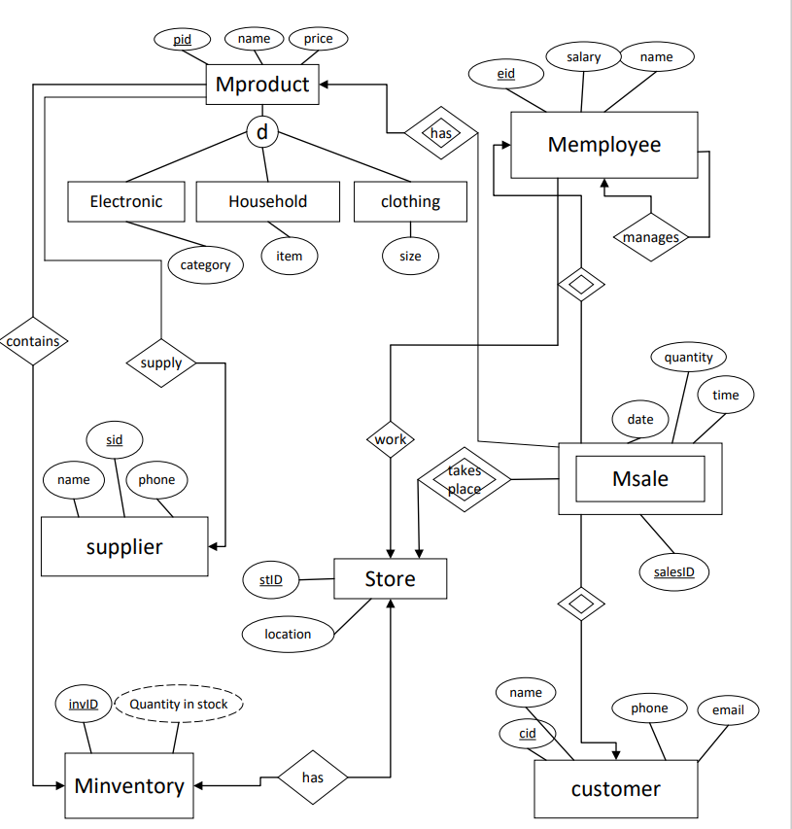

3. Relational Model

Suppliers (Sid, sname, sphone)

Customers (Cid, cname, cphone, email)

Inventory (invID, stID)

stID: references store (stID)

Store (stID, location)

Employees (Eid, salary, ename, mid, stID )

Mid: references employee (eid)

stID: references store (stID)

products(pid, name, price)

Sales (SalesID, date, time, quantity, cid, eid, sid, pid)

cid: references customer(cid)

eid: references employees(eid)

sid: references suppliers(sid)

pid: references product(pid)

Electronics (Pid, pname, price, category, sid, salesID, invID )

Pid: references product (pid)

Sid: references supplier(sid)

SalesID: references Sales(SalesID)

invID: references inventory (invID)

Household: (pid, pname, price, item, sid, salesID, invID)

Pid: references product (pid)

Sid: references supplier(sid)

SalesID: references Sales(SalesID)

invID: references inventory (invID)

clothing(pid, pname, price, size, sid, salesID, invID)

Pid: references product (pid)

Sid: references supplier(sid)

SalesID: references Sales(SalesID)

invID: references inventory (invID)

4. SQL

4.1. Create table

create table suppliers(

Sid number(3) constraint suppliers_Sid_pk primary key,

sname varchar2(20) constraint suppliers_sname_nn not null,

sphone varchar2(20) constraint suppliers_sphone_nn not null

);

create table customers(

Cid number(4) constraint customers_Cid_pk primary key,

cname varchar2(20) constraint customers_cname_nn not null,

cphone varchar2(20) constraint customers_sphone_nn not null,

email varchar2(30) constraint customers_email_nn not null

);

create table store(

stID number(2) constraint store_stID_pk primary key,

location varchar2(40) constraint store_location_nn not null

);

create table Minventory(

invID number(2) constraint Minventory_invID_pk primary key,

stID number(2) constraint Minventory_stID_fk references store(stID)

);

create table Memployees(

Eid number(4) constraint Memployees_Eid_pk primary key,

salary number(7) constraint Memployees_salary_nn not null,

ename varchar2(20) constraint Memployees_ename_nn not null,

Mid number(4) constraint Memployees_Mid_fk references Memployees(Eid),

stID number(2) constraint Memployees_stID_fk references store(stID)

);

create table Mproduct(

pid number(4) constraint Mproduct_pid_pk primary key,

name varchar2(20) constraint Mproduct_name_nn not null,

price number(5) constraint Mproduct_price_nn not null

);

create table Msales(

salesID number(5) constraint Msales_salesID_pk primary key,

mdate date constraint Msales_date_nn not null,

time timestamp constraint Msales_time_nn not null,

quantity number(7) constraint Msales_quantity_nn not null,

Cid number(4) constraint Msales_Cid_fk references customers(Cid),

Eid number(4) constraint Msales_Eid_fk references Memployees(Eid),

sid number(4) constraint Msales_sid_fk references suppliers(sid),

pid number(4) constraint Msales_pid_fk references Mproduct(pid)

);

create table electronics(

elecid number(4) constraint electronics_elecid_fk references Mproduct (pid),

constraint electronics_elecid_pk primary key(elecid),

category varchar2(20) constraint electronics_category_nn not null,

sid number(4) constraint electronics_sid_fk references suppliers(sid),

salesID number(5) constraint electronics_salesID_fk references Msales(salesID),

invID number(2) constraint electronics_invID_fk references Minventory(invID)

);

create table household(

houseid number(4) constraint household_houseid_pk primary key,

constraint household_houseid_fk foreign key(houseid) references Mproduct(pid),

item varchar2(20) constraint household_item_nn not null,

sid number(4) constraint household_sid_fk references suppliers(sid),

salesID number(5) constraint household_salesID_fk references Msales(salesID),

invID number(2) constraint household_invID_fk references Minventory(invID)

);

Create table clothing(

Clothingid number(4) constraint clothing_clothingid_pk primary key,

constraint clothing_clothingid_fk Foreign Key (Clothingid) references Mproduct(pid),

clothing_size varchar2(3) constraint clothing_size_nn not null,

sid number(4) constraint clothing_sid_fk references suppliers(sid),

salesID number(5) constraint clothing_salesID_fk references Msales(salesID),

invID number(2) constraint clothing_invID_fk references Minventory(invID)

);

**4.2. Insert Table**

insert into suppliers(Sid,sname,sphone) values ('001','Sebnem Coban','+90 533 123 45 67');

insert into suppliers(Sid,sname,sphone) values ('002','Raygan Kansoy','+90 533 321 48 67');

insert into suppliers(Sid,sname,sphone) values ('003','Akile Oday','+90 533 234 45 56');

insert into suppliers(Sid,sname,sphone) values ('004','Husnu Bayramoglu','+90 533 678 45 97');

insert into suppliers(Sid,sname,sphone) values ('005','Birol Ozkaya','+90 533 123 45 67');

insert into suppliers(Sid,sname,sphone) values ('006','Halide Saricizmeli','+90 533 789 45 67');

insert into suppliers(Sid,sname,sphone) values ('007','Yesim Kapsil Cirak','+90 533 345 46 63');

insert into suppliers(Sid,sname,sphone) values ('008','Umut Bardak','+90 533 567 45 07');

insert into customers values('1111','Khalid Hamid','+90 533 88 77 616','21903847@emu.edu.tr');

insert into customers values('1112','Zahraa Delbani','+90 533 88 77 600','22701770@emu.edu.tr');

insert into customers values('1113','Rayan Mohammed','+90 533 85 77 612','21903240@emu.edu.tr');

insert into customers values('1114','zahra Chouman','+90 533 83 77 786','21901672@emu.edu.tr');

insert into customers values('1115','Temi Eunice','+90 533 81 77 234','21901521@emu.edu.tr');

insert into customers values('1116','Mahjoob Abobakr','+90 533 48 17 716','21902506@emu.edu.tr');

insert into store values('10','Famagusta');

insert into store values('20','Girne');

insert into store values('30','Lefkosa');

insert into store values('40','Iskele');

insert into store values('50','Lefke');

insert into store values('60','Guzelyurt');

insert into store values('70','Larnaca');

insert into store values('80','Ayia Napa');

insert into Minventory values('11','10');

insert into Minventory values('12','20');

insert into Minventory values('13','30');

insert into Minventory values('14','40');

insert into Minventory values('15','50');

insert into Minventory values('16','60');

insert into Minventory values('17','70');

insert into Minventory values('18','80');

insert into Memployees (Eid, salary, ename, Mid, stID) values(1001,10000,'Kolawole Adeniran',1001,10);

insert into Memployees values(1002,10000,'Hudaifa Ghula',1001,20);

insert into Memployees values(1003,10000,'Ahmed Elfageih',1001,30);

insert into Memployees values(1004,10000,'Henry Ikediego',1001,40);

insert into Memployees values(1005,10000,'Jeremiah Adebiyi',1001,50);

insert into Memployees values(1006,10000,'Alireza Behravesh',1001,60);

insert into Mproduct values(2221,'TV',10000);

insert into Mproduct values(2222,'AC',12000);

insert into Mproduct values(2223,'oven',20000);

insert into Mproduct values(2224,'Table',4000);

insert into Mproduct values(2225,'Cupboard',1000);

insert into Mproduct values(2226,'chair',500);

insert into Mproduct values(2227,'t-shirt',30);

insert into Mproduct values(2228,'pants',40);

insert into Mproduct values(2229,'scarf',100);

insert into Msales(salesID,mdate,time,quantity,cid,eid,sid,pid) values(123, TO_DATE('2023-JAN-01', 'YYYY-MON-DD'), TO_TIMESTAMP('2023-JAN-01 13:00:00', 'YYYY-MON-DD HH24:MI:SS'), 1, 1111, 1001, 001, 2227);

insert into Msales values(124, TO_DATE('2023-FEB-02', 'YYYY-MON-DD'), TO_TIMESTAMP('2023-FEB-02 13:30:00', 'YYYY-MON-DD HH24:MI:SS'), 3, 1112, 1002, 001, 2221);

insert into Msales values(125, TO_DATE('2023-MAR-02', 'YYYY-MON-DD'), TO_TIMESTAMP('2023-MAR-02 14:30:00', 'YYYY-MON-DD HH24:MI:SS'), 3, 1113, 1003, 002, 2222);

insert into Msales values(126, TO_DATE('2023-APR-02', 'YYYY-MON-DD'), TO_TIMESTAMP('2023-APR-02 15:30:00', 'YYYY-MON-DD HH24:MI:SS'), 1, 1114, 1004, 005, 2226);

insert into Msales values(127, TO_DATE('2023-APR-01', 'YYYY-MON-DD'), TO_TIMESTAMP('2023-APR-01 13:30:00', 'YYYY-MON-DD HH24:MI:SS'), 10, 1115, 1005, 006, 2224);

insert into Msales values(128, TO_DATE('2023-MAY-30', 'YYYY-MON-DD'), TO_TIMESTAMP('2023-MAY-30 19:30:00', 'YYYY-MON-DD HH24:MI:SS'),29, 1112, 1003, 005, 2227);

insert into electronics values(2221,'tv',001,123,11);

insert into electronics values(2222,'ac',002,124,12);

insert into electronics values(2223,'oven',003,125,13);

insert into household values(2226,'chair',001,123,11);

insert into household values(2224,'table',006,128,16);

insert into household values(2225,'Cupboard',007,125,17);

insert into clothing values(2227,'S',001,123,11);

insert into clothing values(2228,'M',006,128,16);

insert into clothing values(2229,'XL',007,125,17);

4.3. Update Table

-- Update employees salary

update Memployees

set salary = salary*1.1;

-- Update supplier phone number

update suppliers

set sphone = '+90 533 133 35 67'

where Sid =001;

-- Update customer email

update customers

set email = 'zahraadelbani4@gmail.com'

where Cid = 1112;

-- Update customer email

update customers

set email = 'rayyanmosman@gmail.com'

where Cid = 1113;

-- Update employee store ID

UPDATE Memployees

SET stID = 80

WHERE Eid = 1002;

-- Update product price

UPDATE Mproduct

SET price = 10000

WHERE pid = 2222;

-- Update electronics quantity based on a percentage increase

update Msales

set quantity = quantity * 1.1

where salesID in (

select salesID

from electronics

where elecid = 2221

);

-- Decrease product price by 15%

update Mproduct

set price = price * 0.85

where pid = 2227;

**4.4. Delete Table**

alter table msales

drop primary key cascade;

delete from msales

where quantity < (select avg(quantity) from msales);

alter table customers

drop primary key cascade;

delete from customers

where upper(cname) like '%I%';

alter table suppliers

drop primary key cascade;

delete from suppliers

where upper(sname) like '%KANSOY%';

delete from msales

where eid = (select eid

from memployees

where stid=50 );

delete from electronics

where sid<=2 and upper(category)='TV';

delete from clothing

where salesid=125 or upper(clothing_size)='S';

**4.5. Alter Table**

alter table suppliers

modify sname varchar2(30);

alter table customers

drop constraint customers_email_nn;

alter table customers

add constraint customers_email_uk unique(email);

alter table store

modify location varchar2(30);

alter table store

modify stID number(3);

alter table Minventory

modify invID number(3);

alter table clothing

drop constraint clothing_size_nn;

alter table clothing

add constraint clothing_size_ck CHECK (clothing_size in('S','M','L','XL','XXL')) ;

alter table Memployees

add dob date;

alter table suppliers

modify sphone varchar2(20);

alter table suppliers

modify sname varchar2(30);

alter table customers

modify cphone varchar2(30);

alter table customers

modify cphone varchar2(30);

alter table memployees

drop column dob;

**4.6. Drop Table**

drop table suppliers cascade constraints;

drop table customers cascade constraints;

drop table store cascade constraints;

drop table Minventory cascade constraints;

drop table Memployees cascade constraints;

drop table Mproduct cascade constraints;

drop table Msales cascade constraints;

drop table electronics cascade constraints;

drop table clothing cascade constraints;

drop table household cascade constraints;

4.7. Queries

-- Calculate the total sales quantity and revenue for each product

select p.name, SUM(s.quantity) as total_quantity, sum(s.quantity * p.price) as

from Mproduct p

join Msales s on p.pid = s.pid

group by p.name;

-- Find the average salary of employees in each store

select e.stID, avg(e.salary) as average_salary

from Memployees e

group by e.stID;

-- Retrieve the names of all suppliers who have supplied electronics products

select distinct s.sname

from suppliers s

join electronics e on s.Sid = e.sid;

-- Find the products that have never been sold

select p.name

from Mproduct p

left join Msales s on p.pid = s.pid

where s.salesID is null;

-- Get the total revenue for each supplier from electronics sales

select p.name, sum(s.quantity * p.price) as total_revenue

from Mproduct p

join Msales s on p.pid = s.pid

group by p.name

order by total_revenue desc;

-- Retrieve the customers who have purchased products from all categories (electronics, household, and clothing)

select c.cname

from customers c

where (

select count(distinct category)

from Msales s

join Mproduct p on s.pid = p.pid

left join electronics e on p.pid = e.elecid

left join household h on p.pid = h.houseid

left join clothing cl on p.pid = cl.Clothingid

where s.Cid = c.Cid

) = 3;

**Conclusion**

Throughout this project, we embarked on a journey to design and implement a relational database that met specific requirements. Using the Oracle Application Express, we successfully transformed our design into a functional database application.

This project provided us with a deep understanding of efficient and effective database design. We learned to carefully analyze requirements, identify key entities, and create a well-structured schema. By employing normalization techniques, we optimized data storage and improved overall performance.

Working with the Oracle Application Express allowed us to create user-friendly interfaces, implement data validation, and generate insightful reports using SQL queries. These practical experiences will undoubtedly benefit us in future projects.

Overall, this project has equipped us with the necessary skills and knowledge to design and implement efficient relational databases. We are now better prepared to tackle complex challenges and ensure our databases meet the unique requirements of each scenario.